# Coding Cheat Sheet

## Task 3: Chat Bot

**Wherever there is the word BLANK, you need to replace this with your own code.**

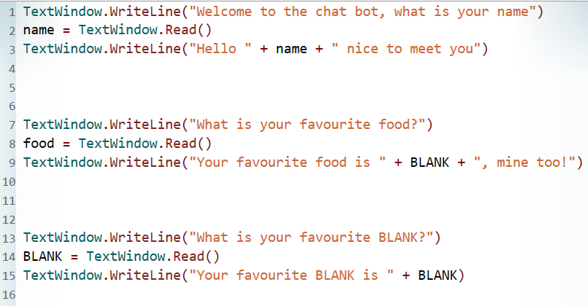

Now insert your own question!

# 